**20BCS042 | MOHD ADIL**

**ASSIGNMENT 1**

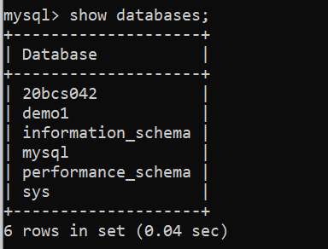Viewing The Existing Databases, Switching to the Desired Database:

Using 20BCS042 database CREATING tables:

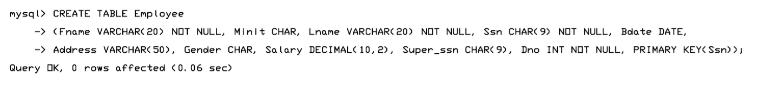

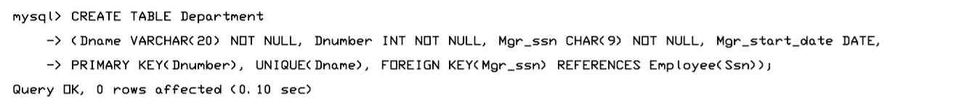

DESCRIBING TABLES:

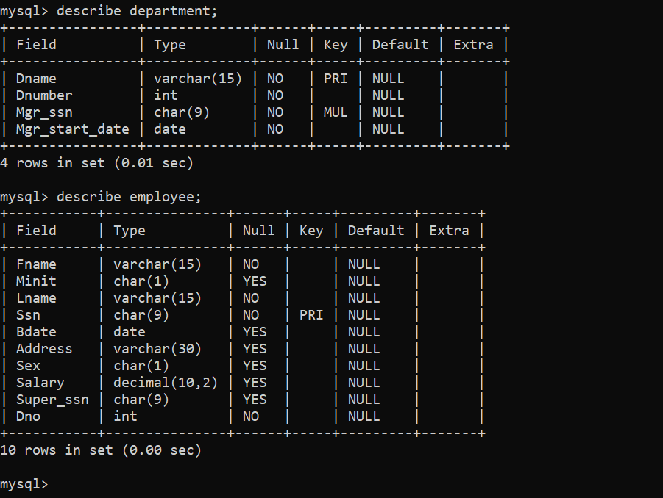

Inserting values into the Table (Employee):

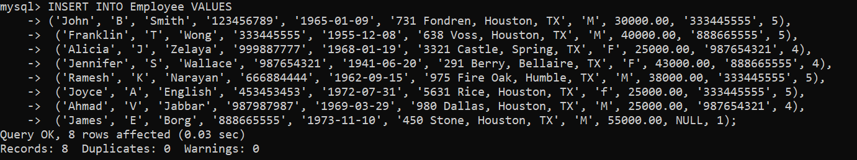

Selecting everything from the Table (Employee):

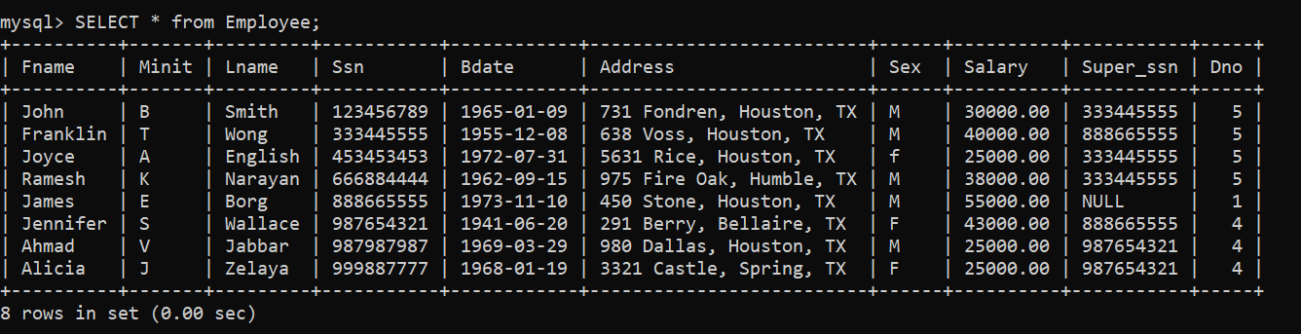

Inserting values into the Table (Department):

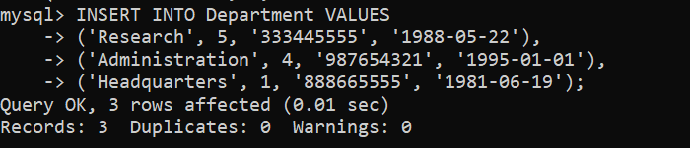

Selecting everything from the Table (Department):

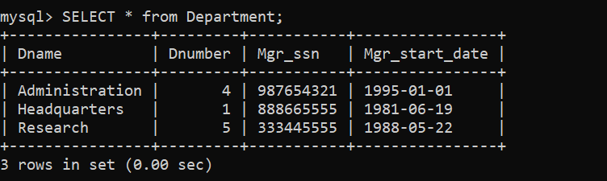

**Queries using the created tables**

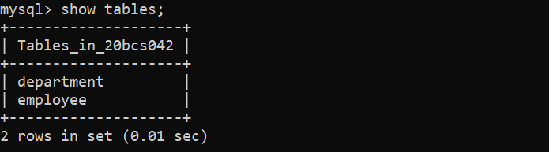Query-1: Viewing the tables in the database.

Query-2: Retrieve the birth date and address of the employee(s) whose name is ‘John B. Smith’.

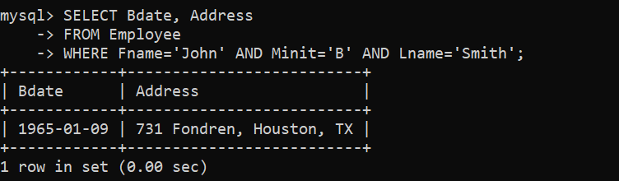

Query-3: Retrieve the name and address of all employees who work for the ‘Research’ department.

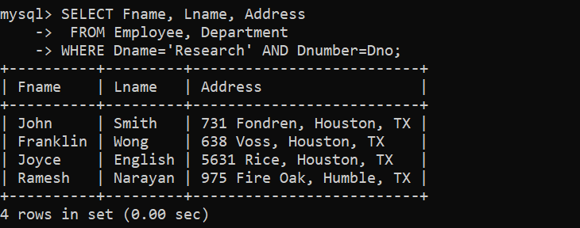

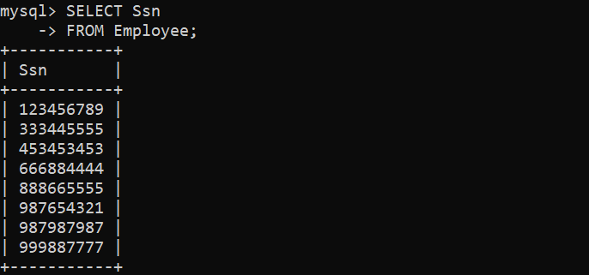Query-4: Select all EMPLOYEE Ssns in the database.

Query-5: Select all combinations of EMPLOYEE Ssn and DEPARTMENT Dname in the database.

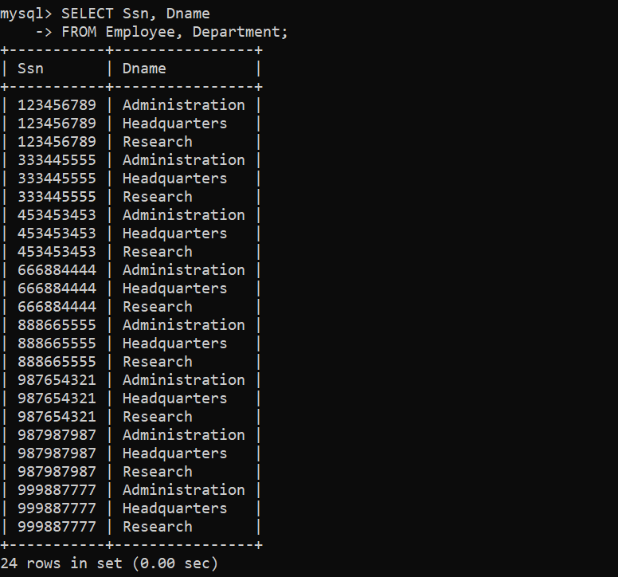

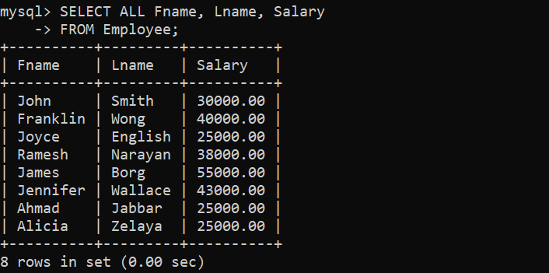Query-6: Retrieve the salary of every employee. Query-8: Retrieve all employees whose address is in Houston,

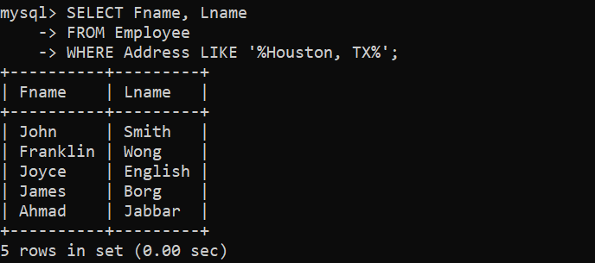

Query-7: Retrieve all distinct salary values.

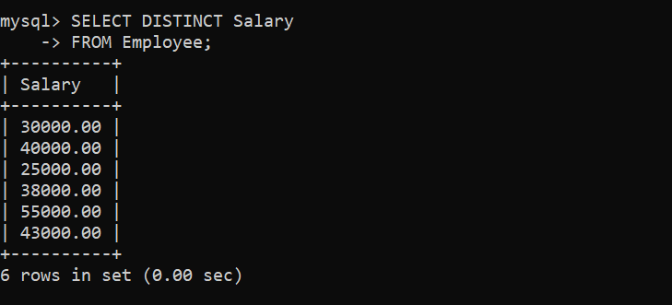

Query-9: Retrieve all employees in department 5 whose salary is between $30,000 and $40,000.

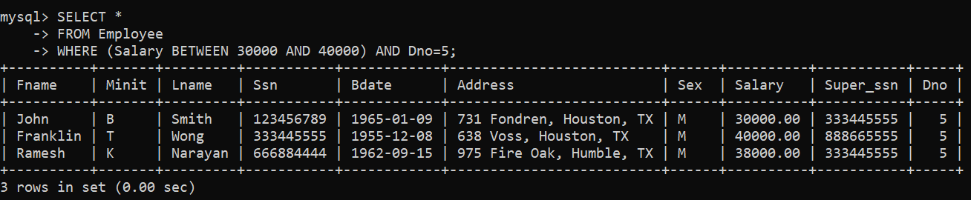

Query-10: Retrieve all employees whose supervisor is ‘James E. Borg’.

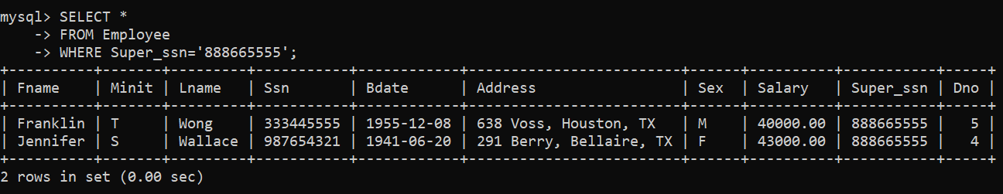

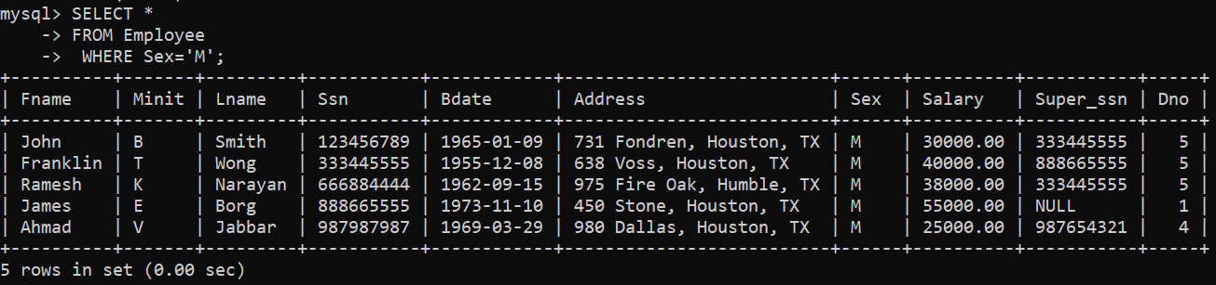Query-11: Retrieve all male employees from the database.